SIMATS ENGINEERING

SAVEETHA INSTITUTE OF MEDICAL AND TECHNICAL SCIENCES

Department of Computer Science and Engineering (AI)
CSA0909 - PROGRAMMING IN JAVA

COURSE ASSIGNMENT REPORT
DESIGN AND IMPLEMENTATION OF A
UNIVERSITY EVENT MANAGEMENT SYSTEM IN JAVA

Submitted By

T Deekshith (192472253)
Department of Computer Science and Engineering (AI)

1. Problem Statement

Universities conduct technical workshops, seminars, coding contests, cultural programmes, sports activities and other academic events throughout the year. When event details and student registrations are maintained through separate manual records or scattered files, it becomes difficult to create, update, search and remove event information consistently. Duplicate registrations, invalid student details and incorrect event references can also occur when validation is performed manually.
As part of the Programming in Java course assignment, the proposed system is a Java-based University Event Management System with a graphical user interface. The application is designed to allow an administrator or event coordinator to add, search, update and delete university events and to register students for existing events. The system also demonstrates Java Applet programming concepts, the Delegation Event Model, AWT components, Java I/O Streams, object serialization, password hashing, JDBC connectivity and exception handling.
The system maintains event and registration information using both binary file persistence and a MySQL relational database. Sensitive registration credentials are not stored as plain text; instead, the password is converted into a SHA-256 digest before persistence. This provides a single academic application in which the required Java concepts are integrated into a practical event-management workflow.

2. Objective

The objective of this assignment is to design, implement and evaluate a Java-based University Event Management System that combines GUI programming, event handling, file persistence, security and database connectivity. Specifically, the project aims to:
- Develop an AWT-based desktop interface using Frame, Panel, Label, TextField, Button, Choice, TextArea and suitable layout managers.
- Demonstrate the Delegation Event Model using ActionEvent, ActionListener and actionPerformed() for button-driven operations.
- Provide complete event management operations including Add, Update, Search, Delete, Clear and Exit.
- Provide student event registration, registration search and registration deletion with validation and duplicate checking.
- Use Java I/O Streams and ObjectOutputStream/ObjectInputStream to serialize and deserialize Event and Registration objects.
- Apply SHA-256 hashing through java.security.MessageDigest so that raw passwords are not stored in files or the database.
- Establish JDBC connectivity with a local MySQL/MariaDB-compatible database and implement INSERT, SELECT, UPDATE and DELETE operations through DAO classes.
- Demonstrate traditional Java Applet lifecycle methods for academic purposes while keeping the primary executable application as an AWT Frame.
- Handle invalid input, missing records, file errors and SQL errors without terminating the application unexpectedly.

3. Requirements and Environment Used

3.1 Functional Requirements
- Create and store a university event using Event ID, event name, event date, venue and event type.
- Search an event by its unique Event ID and display the retrieved details.
- Update existing event information and persist the changes.
- Delete an event and remove associated registration records where applicable.
- List or display existing event information through the GUI.
- Register a student for an existing event using Student ID, student name, email, password and Event ID.
- Reject registration when the referenced event does not exist or when the same student is already registered for the same event.
- Validate mandatory fields, numeric identifiers and email format before processing.
- Hash the password using SHA-256 before storing a Registration object.
- Persist events in data/events.dat and registrations in data/registrations.dat using object serialization.
- Synchronize operations with the MySQL database using JDBC and PreparedStatement.
- Provide Clear and Exit functions and display meaningful status/error messages in the GUI.

3.2 Environment Specifications
Component | Specification
Programming Language | Java; project compiled for Java 8 bytecode for compatibility with the installed Java 8 runtime.
Compiler | javac 22.0.2 with --release 8 used for compilation.
Runtime | Java 8 (1.8.0_431) used to execute the compiled application.
IDE / Editor | Visual Studio Code / Antigravity IDE.
GUI Toolkit | Java AWT (java.awt, java.awt.event).
Database | XAMPP local MySQL/MariaDB-compatible server, default port 3306.
Database Administration | phpMyAdmin through XAMPP.
Database Driver | MySQL Connector/J JDBC driver (lib/mysql-connector-j.jar).
Database API | JDBC: Connection, PreparedStatement, Statement, ResultSet.
Persistence | Java Object Serialization using ObjectOutputStream and ObjectInputStream.
Security API | java.security.MessageDigest with SHA-256.
Operating System | Windows 10/11 development environment.
Storage | Local project folder with data/ binary persistence files.

4. Design / Proposed Solution

4.1 Class Structure and Component Design
The system is divided into model, persistence, security, GUI and launcher components. Event and Registration represent the application data objects. FileManager and RegistrationFileManager provide binary file persistence. EventDAO and RegistrationDAO provide database access. DatabaseConnection centralizes JDBC configuration. HashUtil performs password hashing. EventManagementGUI provides the AWT interface and event handling, while UniversityEventApplet demonstrates the traditional applet lifecycle.
Event
├─ eventId
├─ eventName
├─ eventDate
├─ venue
└─ eventType
Registration
├─ registrationId
├─ studentId
├─ studentName
├─ email
├─ eventId
├─ passwordHash
└─ registrationDate
Persistence Layer
├─ FileManager
├─ RegistrationFileManager
├─ EventDAO
└─ RegistrationDAO
Support Layer
├─ DatabaseConnection
└─ HashUtil
Presentation Layer
├─ EventManagementGUI (AWT Frame + ActionListener)
└─ UniversityEventApplet (Applet demonstration)
Application Entry
└─ Main
Figure 1. Logical class/component structure of the University Event Management System

4.2 Database Schema

The relational database is named university_events. The main database tables are events and registrations. The registrations table references the events table through event_id. A uniqueness rule on the student-event combination is used to prevent duplicate registration for the same event.
Table | Key Columns | Purpose
events | event_id (PK), event_name, event_date, venue, event_type | Stores university event details.
registrations | registration_id (PK), student_id, student_name, email, event_id (FK), password_hash, registration_date | Stores student registration information and hashed credential.

CREATE DATABASE IF NOT EXISTS university_events;
CREATE TABLE events (
event_id INT PRIMARY KEY,
event_name VARCHAR(100) NOT NULL,
event_date VARCHAR(30) NOT NULL,
venue VARCHAR(100) NOT NULL,
event_type VARCHAR(50) NOT NULL
);
CREATE TABLE registrations (
registration_id INT PRIMARY KEY AUTO_INCREMENT,
student_id INT NOT NULL,
student_name VARCHAR(100) NOT NULL,
email VARCHAR(150) NOT NULL,
event_id INT NOT NULL,
password_hash VARCHAR(64) NOT NULL,
registration_date VARCHAR(30) NOT NULL,
FOREIGN KEY (event_id) REFERENCES events(event_id)
);
Figure 2. Simplified database definition used by the project

4.3 GUI Layout Plan
EventManagementGUI is implemented as a single AWT Frame. The interface is divided into an event-management area and a student-registration area. Each area contains labels and input fields together with operation buttons. Choice is used for event type selection, while a TextArea/status area is used to display results and system messages.

GUI Area | Controls | Operations
Event Management | TextField, Choice, Button, Label | Add, Search, Update, Delete, Clear
Student Registration | TextField, Button, Label | Register, Search Registration, Delete Registration, Clear
Status / Output | TextArea / Dialog | Success messages, validation warnings and error information
Window Control | Frame + WindowAdapter | Close / Exit operation

5. Algorithm / Pseudocode
The following pseudocode describes the major operations implemented by EventManagementGUI, the file managers and the DAO classes.

5.1 Add Event
START
READ Event ID, Event Name, Event Date, Venue and Event Type
IF any required field is empty
DISPLAY validation warning
STOP
IF Event ID is not numeric
DISPLAY numeric-input warning
STOP
CREATE Event object
CHECK whether Event ID already exists
IF duplicate exists
DISPLAY duplicate warning
STOP
SAVE Event object using FileManager
INSERT Event record using EventDAO when database is available
DISPLAY success message
END

5.2 Search Event
START
READ Event ID
VALIDATE numeric Event ID
SEARCH Event ID in file persistence
IF not found and database is available
SEARCH using EventDAO
IF event is found
DISPLAY event details in GUI
ELSE
DISPLAY "Event not found"
END

5.3 Update Event
START
READ Event ID and updated event fields
VALIDATE required fields
FIND existing event
IF event does not exist
DISPLAY warning
ELSE
UPDATE Event object
WRITE updated collection to events.dat
UPDATE corresponding row using EventDAO
DISPLAY success message
END

5.4 Delete Event
START
READ Event ID
VALIDATE numeric ID
CHECK whether event exists
IF not found
DISPLAY warning
ELSE
DELETE event from serialized file
DELETE associated registrations where required
DELETE event from database
DISPLAY success message
END

5.5 Register Student
START
READ Student ID, Student Name, Email, Password and Event ID
IF required field is empty
DISPLAY validation warning
IF email does not match required pattern
DISPLAY email warning
IF Event ID is not numeric
DISPLAY numeric-input warning
CHECK that referenced Event exists
CHECK duplicate Student ID + Event ID registration
HASH password using SHA-256
CREATE Registration object with passwordHash
SAVE Registration using RegistrationFileManager
INSERT Registration using RegistrationDAO when database is available
DISPLAY registration success
END

5.6 Password Hashing
FUNCTION hashPassword(password):
CREATE MessageDigest instance for SHA-256
CONVERT password into UTF-8 bytes
digest = messageDigest.digest(passwordBytes)
CONVERT digest bytes to hexadecimal string
RETURN 64-character hexadecimal hash
END

5.7 Database CRUD
FUNCTION add/update/delete/search:
OPEN JDBC Connection
PREPARE parameterized SQL statement
SET values using PreparedStatement
EXECUTE update or query
READ ResultSet for retrieval operations
CLOSE JDBC resources using try-with-resources
RETURN operation result
END

6. Implementation / Source Code
The implementation is organized into separate Java classes so that each required concept can be demonstrated and explained independently. The following table maps the project files to their responsibilities.
File | Purpose
Main.java | Application entry point; seeds sample file data when required and launches the AWT GUI.
Event.java | Serializable event model containing event ID, name, date, venue and type.
Registration.java | Serializable student registration model containing the SHA-256 password hash.
EventManagementGUI.java | AWT Frame, input forms, buttons, validation, dialogs and ActionListener handling.
FileManager.java | Serialization-based CRUD operations for Event objects in data/events.dat.
RegistrationFileManager.java | Serialization-based CRUD operations for Registration objects in data/registrations.dat.
HashUtil.java | SHA-256 hashing using MessageDigest.
DatabaseConnection.java | Loads database properties and creates JDBC connections.
EventDAO.java | JDBC CRUD operations for the events table.
RegistrationDAO.java | JDBC CRUD operations for the registrations table.
UniversityEventApplet.java | Traditional Java Applet lifecycle demonstration.
SystemVerificationTest.java | Automated verification of hashing, serialization, validation, JDBC/fallback and applet lifecycle.
sql/database.sql | Database and table creation script with project constraints/sample data.

6.1 Event and Registration Model - Encapsulation and Serialization
public class Event implements Serializable {
private static final long serialVersionUID = 1L;
private int eventId;
private String eventName;
private String eventDate;
private String venue;
private String eventType;
public Event(int eventId, String eventName, String eventDate,
String venue, String eventType) {
this.eventId = eventId;
this.eventName = eventName;
this.eventDate = eventDate;
this.venue = venue;
this.eventType = eventType;
}
}
Both Event and Registration implement Serializable. Their fields are private and are accessed through getters and setters, demonstrating encapsulation. The serialVersionUID value provides a stable serialization identifier.

6.2 File I/O - Object Serialization and Deserialization
try (FileOutputStream fos = new FileOutputStream(file);
ObjectOutputStream oos = new ObjectOutputStream(fos)) {
oos.writeObject(events);
}
try (FileInputStream fis = new FileInputStream(file);
ObjectInputStream ois = new ObjectInputStream(fis)) {
return (List<Event>) ois.readObject();
}
The file managers create the data directory when required and store serialized lists in binary .dat files. The same objects can later be reconstructed using ObjectInputStream, providing persistence across application restarts.

6.3 Cryptographic Hashing with SHA-256
MessageDigest md = MessageDigest.getInstance("SHA-256");
byte[] digest = md.digest(password.getBytes(StandardCharsets.UTF_8));
StringBuilder hex = new StringBuilder();
for (byte b : digest) {
hex.append(String.format("%02x", b & 0xff));
}
return hex.toString();
The raw password entered in the registration form is transformed into a fixed 64-character hexadecimal SHA-256 digest. The Registration object stores passwordHash rather than the original password. This satisfies the assignment requirement to demonstrate hashing for a selected sensitive field.

6.4 JDBC Connectivity and DAO Operations
dbUrl = "jdbc:mysql://" + host + ":" + port + "/" + dbName
+ "?useSSL=false&allowPublicKeyRetrieval=true"
+ "&serverTimezone=UTC&createDatabaseIfNotExist=true";
Connection conn = DriverManager.getConnection(
dbUrl, dbUser, dbPassword);
String sql = "INSERT INTO events "
+ "(event_id, event_name, event_date, venue, event_type) "
+ "VALUES (?, ?, ?, ?, ?)";
try (Connection conn = DatabaseConnection.getConnection();
PreparedStatement pstmt = conn.prepareStatement(sql)) {
pstmt.setInt(1, event.getEventId());
pstmt.setString(2, event.getEventName());
pstmt.setString(3, event.getEventDate());
pstmt.setString(4, event.getVenue());
pstmt.setString(5, event.getEventType());
pstmt.executeUpdate();
}
EventDAO and RegistrationDAO use parameterized PreparedStatement objects for database operations. The DAOs provide create, retrieve/search, update and delete operations and use ResultSet for retrieval. Database configuration is read from db.properties, making the connection settings easy to modify for the local XAMPP environment.

6.5 Delegation Event Model - ActionListener Event Dispatch
public class EventManagementGUI extends Frame
implements ActionListener {
public void actionPerformed(ActionEvent e) {
Object source = e.getSource();
if (source == addEventButton) {
handleAddEvent();
} else if (source == searchEventButton) {
handleSearchEvent();
}
// update, delete, register, clear and exit
}
}
Buttons act as event sources. When a user clicks a button, AWT creates an ActionEvent and delegates it to the registered ActionListener. The actionPerformed() method identifies the source and calls the corresponding handler. WindowAdapter is used for window-closing behavior.

6.6 Traditional Java Applet Lifecycle Demonstration
public class UniversityEventApplet extends Applet
implements ActionListener {
public void init() { ... }
public void start() { ... }
public void paint(Graphics g) { ... }
public void stop() { ... }
public void destroy() { ... }
}
The separate UniversityEventApplet class demonstrates init(), start(), paint(), stop() and destroy(). The primary application remains a Frame because browser-based Java Applets are obsolete in modern Java and web browsers. For this assignment, the applet is retained as an academic demonstration of the requested programming concept.

7. Test Cases and Expected/Actual Results
The following test matrix is based on the implemented functionality in EventManagementGUI, the file managers, the DAO classes, HashUtil and SystemVerificationTest. The application was successfully compiled using --release 8 and launched using the installed Java 8 runtime. The detailed feature-level Actual Result and Status should be finalized from the team's live XAMPP/database execution screenshots.
ID | Category | Scenario | Input | Expected Result | Actual Result | Status
TC-01 | Event CRUD | Add valid event | ID=104; AI Symposium; 25-10-2026; Auditorium; Seminar | Event saved and success message displayed | To be verified during final live test | Pending
TC-02 | Validation | Empty mandatory event field | Event name blank | Operation blocked with validation warning | To be verified | Pending
TC-03 | Validation | Non-numeric Event ID | ID=ABC | NumberFormatException handled; warning shown | To be verified | Pending
TC-04 | Event CRUD | Search existing event | Event ID=101 | Event details displayed | To be verified | Pending
TC-05 | Event CRUD | Search missing event | Event ID=9999 | Event-not-found message displayed | To be verified | Pending
TC-06 | Event CRUD | Update event | ID=101; changed venue | File and DB record updated | To be verified | Pending
TC-07 | Event CRUD | Delete event | ID=103 | Event removed; linked registrations handled | To be verified | Pending
TC-08 | Registration | Valid student registration | 1003; Ananya; ananya@univ.edu; Event 101 | Password hashed; registration stored | To be verified | Pending
TC-09 | Validation | Registration for missing event | Event ID=8888 | Registration blocked | To be verified | Pending
TC-10 | Validation | Duplicate student-event registration | Student 1001; Event 101 | Duplicate rejected | To be verified | Pending
TC-11 | Validation | Invalid email | invalid-email-format | Warning displayed; no registration | To be verified | Pending
TC-12 | Validation | Blank password | Password empty/space | Warning displayed; no registration | To be verified | Pending
TC-13 | Registration | Search registration | Registration ID=1 | Registration details retrieved | To be verified | Pending
TC-14 | Registration | Delete registration | Registration ID=2 | Registration removed | To be verified | Pending
TC-15 | GUI | Clear Event fields | Click CLEAR | Event fields reset | To be verified | Pending
TC-16 | GUI | Clear Registration fields | Click CLEAR | Registration fields reset | To be verified | Pending
TC-17 | Serialization | Serialize Event | Event object | events.dat contains serialized object data | To be verified | Pending
TC-18 | Serialization | Deserialize Event | events.dat | Event object reconstructed correctly | To be verified | Pending
TC-19 | Security | SHA-256 length/determinism | student123 | 64 hexadecimal characters; same input gives same hash | To be verified | Pending
TC-20 | Security | Plaintext password check | MySecretPass99 | Only hash persisted | To be verified | Pending
TC-21 | Applet | Lifecycle execution | init→start→paint→stop→destroy | Lifecycle methods execute without exception | To be verified | Pending
TC-22 | JDBC/Fallback | Database online/offline | XAMPP MySQL active / inactive | JDBC persistence when online; file persistence fallback when offline | To be verified | Pending

7.1 Automated Verification Suite
SystemVerificationTest.java groups checks into SHA-256 hashing, Event serialization, Registration serialization, input validation, database connectivity/fallback and Applet lifecycle execution. It uses assertions printed as [PASS] or [FAIL] and reports the final passed-test count. The suite is useful for demonstrating that core non-GUI components can be verified systematically.
javac --release 8 -cp "lib/mysql-connector-j.jar" -d out src\*.java
java -cp "out;lib/mysql-connector-j.jar" SystemVerificationTest

8. Execution Screenshots / Output
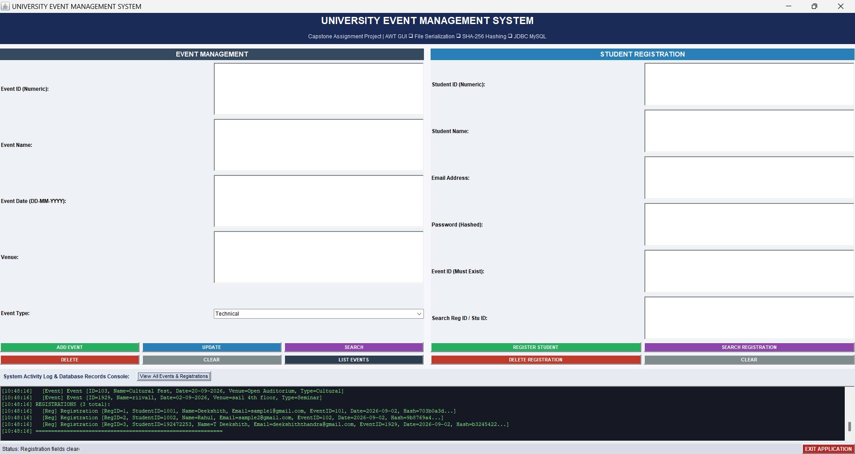

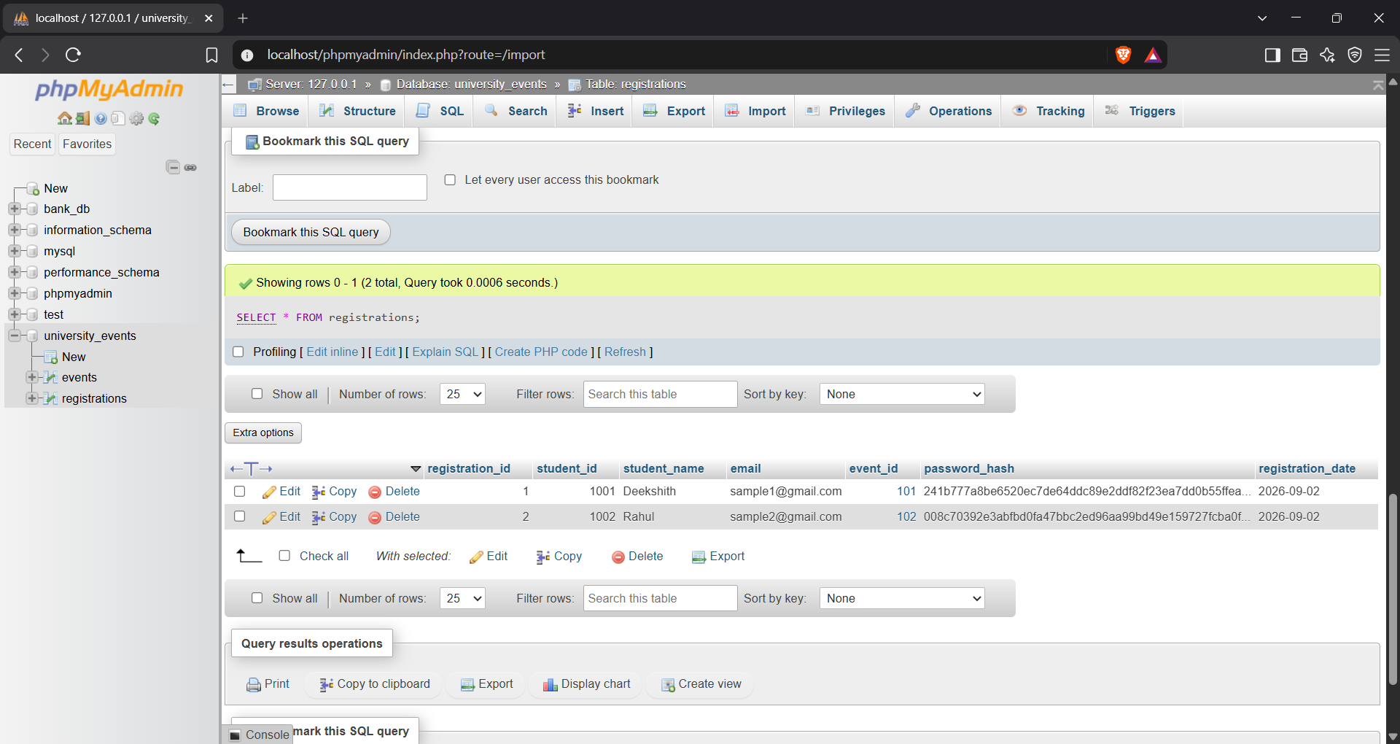
Database
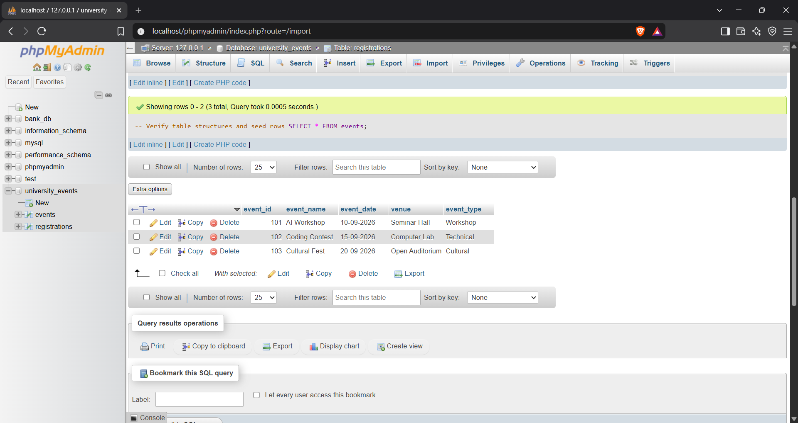

9. Analysis and Discussion
The University Event Management System integrates the major Java programming concepts required by the assignment into a single application. The design separates the user interface from file persistence and database persistence, making each part easier to test and explain during a viva.
Concept | How it is satisfied
Encapsulation | Event and Registration data members are private and accessed through constructors, getters and setters.
Serialization | Event and Registration implement Serializable and are persisted through ObjectOutputStream/ObjectInputStream.
File I/O Streams | FileOutputStream/FileInputStream provide binary file persistence in the data directory.
Hashing | HashUtil uses MessageDigest with SHA-256 to store a one-way digest instead of the raw password.
JDBC | DatabaseConnection creates JDBC connections; DAO classes use PreparedStatement and ResultSet for CRUD/retrieval.
MySQL Database | university_events stores events and registrations with primary/foreign-key relationships.
AWT | EventManagementGUI uses Frame, Panel, Label, TextField, Button, Choice, TextArea and layout managers.
Delegation Event Model | Buttons generate ActionEvent objects and delegate handling to the ActionListener implementation.
Exception Handling | Input parsing, I/O and SQL operations are protected with validation, try-catch blocks and resource-safe statements.
Applet Programming | UniversityEventApplet demonstrates init, start, paint, stop and destroy lifecycle methods.

9.1 Design Choice Rationale
AWT was selected because the assignment explicitly requires AWT components and layout managers. The Frame-based GUI is lightweight and makes the Delegation Event Model visible for academic demonstration. Object serialization was selected for the file layer because Event and Registration are naturally represented as serializable Java objects. A separate DAO layer was selected for JDBC so that SQL operations remain isolated from GUI code. PreparedStatement was preferred over manually concatenated SQL because it provides parameterized queries and clearer separation between SQL and input values.

9.2 Exception-Handling Coverage
- NumberFormatException is handled when numeric Event ID, Student ID or Registration ID input cannot be converted to an integer.
- IOException is handled by the file persistence classes when reading or writing serialized files.
- ClassNotFoundException is handled during deserialization when a stored class cannot be resolved.
- SQLException is handled by JDBC methods and reported to the application instead of silently failing.
- Validation prevents empty fields, invalid email addresses, missing event references and duplicate student-event registrations before persistence.
- Database connection failure can be detected, while the file persistence layer remains available for offline operation.

10. Conclusion
The University Event Management System provides a practical Java implementation for creating and maintaining university event information and student registrations. The system combines an AWT graphical interface with the Delegation Event Model, object serialization, file I/O, SHA-256 hashing, JDBC connectivity and relational database CRUD operations.
The project demonstrates that the required Java concepts can be integrated rather than implemented as isolated examples. Event and Registration objects model the application data, FileManager and RegistrationFileManager provide local persistence, DAO classes provide database access, HashUtil protects registration credentials, and EventManagementGUI coordinates user actions through event listeners.
The traditional Applet component is retained as an academic demonstration of the requested lifecycle methods, while the main application is implemented as a desktop AWT Frame so it can be executed in the current development environment. Overall, the project provides a coherent demonstration of Java GUI programming, persistence, security, database connectivity and exception handling.

11. Individual Contribution of Group Members
The following responsibility mapping is recommended for the three-member team. Replace the placeholders with the actual names and register numbers before submission. The contributions should reflect the work actually completed by each member.

Member | Register No. | Contribution
T Deekshith | 192472253 | AWT GUI design and implementation; Frame/Panel layout; Labels, TextFields, Buttons, Choice and TextArea; Delegation Event Model; ActionListener handling; WindowAdapter; input validation and GUI integration.
Vasudeva Naidu | 192472305 | Event and Registration model classes; Serializable implementation; ObjectOutputStream/ObjectInputStream file persistence; FileManager and RegistrationFileManager; SHA-256 hashing using MessageDigest; persistence validation.
Manoj Kumar | 192472395 | XAMPP/phpMyAdmin database setup; university_events schema; DatabaseConnection; EventDAO and RegistrationDAO; JDBC PreparedStatement CRUD operations; SQL testing and database verification.
All Members | — | System integration, functional testing, debugging, execution screenshots, documentation, presentation preparation and final report review.

12. References
- H. Schildt, Java: The Complete Reference, McGraw Hill.
- Oracle Corporation, Java Platform, Standard Edition API Documentation.
- Oracle Corporation, Java Tutorials / Documentation on AWT and Event Handling.
- Oracle Corporation, Java I/O and Object Serialization Documentation.
- Oracle Corporation, Java Security MessageDigest API Documentation.
- Oracle Corporation, JDBC API Documentation.
- Oracle Corporation, MySQL Reference Manual.
- MySQL, MySQL Connector/J Developer Guide.
- XAMPP Documentation for local Apache, MySQL/MariaDB and phpMyAdmin development environments.

13. One-Page Write-up

University Event Management System in Java – Summary
Problem: Universities manage many technical, academic, cultural and sports events, and maintaining event and student registration information manually can lead to duplicate records, invalid entries and inconsistent updates. This project develops a Java desktop application that centralizes event creation, event searching, event updating, event deletion and student registration through a graphical interface.
Design: The application uses Java AWT to create the user interface with Frame, Label, TextField, Button, Choice and TextArea components. The Delegation Event Model connects GUI buttons to ActionListener handlers through ActionEvent objects. Event and Registration are serializable model classes. FileManager and RegistrationFileManager store objects in events.dat and registrations.dat, while EventDAO and RegistrationDAO provide JDBC access to the university_events database.
Database and Validation: JDBC connections are configured through db.properties and use the local XAMPP MySQL/MariaDB-compatible server. PreparedStatement is used for parameterized SQL operations, while ResultSet is used for retrieval. The GUI validates mandatory fields, numeric identifiers, email format, event existence and duplicate student-event registration. File, database and input-related exceptions are handled so that errors are reported without unnecessarily terminating the application.
Result and Learning: The completed system demonstrates the core requirements of the Java assignment in one integrated application: AWT GUI programming, Delegation Event Model, Java I/O Streams, serialization, SHA-256 hashing, JDBC CRUD, database relationships and exception handling. A separate UniversityEventApplet class also demonstrates the traditional applet lifecycle required by the assignment. The project provided practical experience in connecting Java classes, GUI events, local persistence and database operations into a coherent event-management solution.
For final submission, the team should attach actual screenshots for the GUI, event CRUD operations, registration, hashing evidence, serialized files, phpMyAdmin records and automated verification output. The individual contribution paragraph should also be customized by each student to describe only the work actually performed.
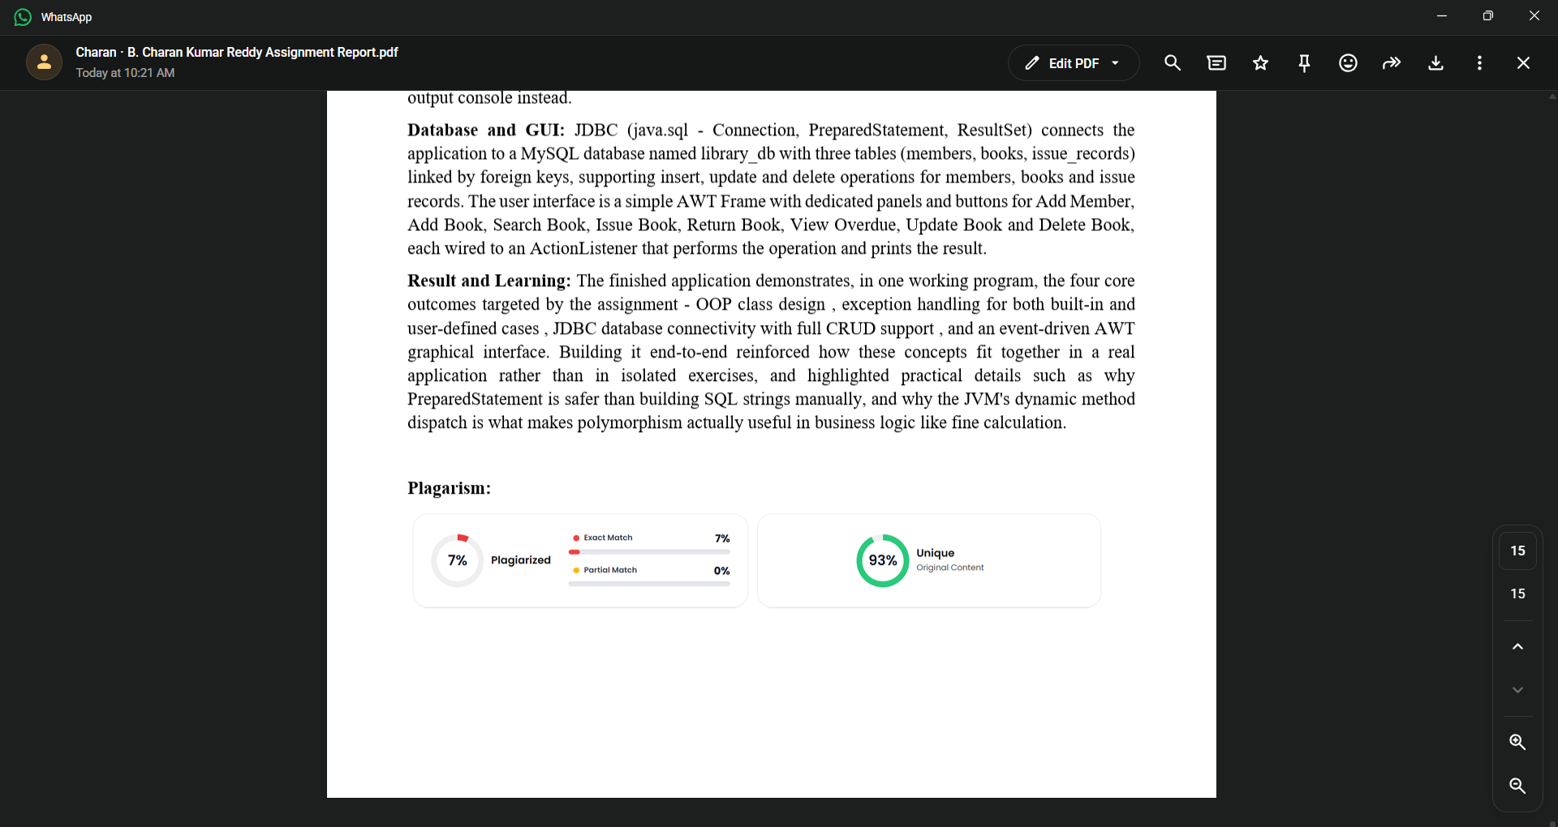
Plagarism:

